**MEDIA RELEASE**

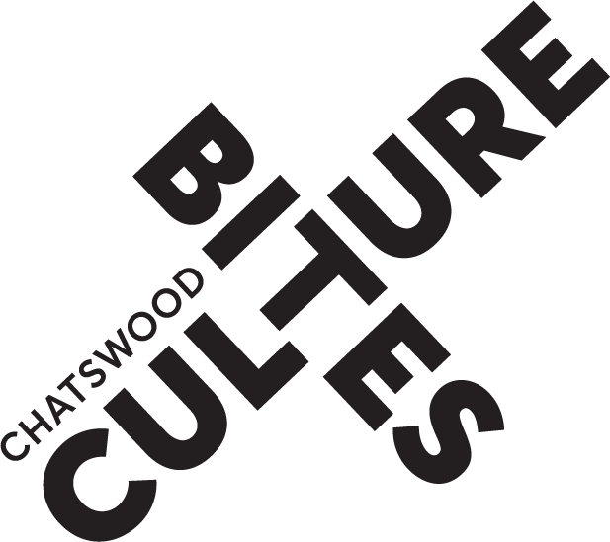

**JAZZ AT THE LOUNGE**

**Indulge in a series of swinging bands and**

**smooth vocals**

JAZZ AT THE LOUNGE presented by Willoughby City Council that kicked off with an incredible performance by Simon Tedeschi and George Washingmachine is proving hugely popular. The series showcases the sounds of swinging jazz bands and smooth vocals from the best musicians and renowned Australian voices on the international jazz scene.

The series continues with three more amazing concerts featuring **GREGG ARTHUR on 10 October**, **MARSALA on 7 November** and finishing on **5 December** with **HETTY KATE QUARTET**.

**GREGG ARTHUR**

**The Duke Ellington Songbook**

**Thursday 10 October**

Endorsed by the biggest names in jazz and praised by his contemporaries and the press, Australian vocalist and composer Gregg Arthur follows in the footsteps of Frank Sinatra, Mel Tormé, and Tony Bennett as one of the great interpreters of classic jazz standards.

Gregg Arthur takes the stage with Australian jazz legends pianist **Peter Locke**, bassist **Craig Scott**, drummer **Andrew Dickeson** for this new concert performing the brilliant songbook of Duke Ellington, including Caravan, Don’t Get Around Much Anymore, Take the A Train and so much more.

Arthur said *"Jazz fans and musicians alike are very excited about the beautiful new venue, The Lounge, at Chatswood Concourse. This world-class showroom is a wonderful addition to Sydney's music scene, and its sophisticated style is perfect for our performance of classic Duke Ellington songs."*

**MARSALA**

**World Music and Jazz**

**Thursday 7 November**

Performing around the world for over 25 years, Marsala presents ‘the world’ in music, from gypsy, tango, salsa, samba, African township tunes to French rap and Italian jazz.

Led by the charismatic **Joseph Zarb** on vocals and guitar, some of the incredible featured musicians in Marsala include **Lupco Stojcevski** on saxophone in the Macedonian tradition of music, **Gino Pengue** on guitar, **Sam Golding** on trumpet, **Brett Hirst** on bass, and extraordinary multi-instrumentalist, **Jess Ciampa** on drums and percussion.

Zarb said when describing Marsala *“Discovering the immense beauty of one another and our cultures through the music traditions. We take you around the world, singing songs in 16 languages. We laugh and cry and dance and sing together. Music is the one language that everyone understands.”*

**HETTY KATE QUARTET**

**The American Songbook**

**Thursday 5 December**

Direct from Paris, sublime British-Australian jazz vocalist Hetty Kate presents a sparkling selection of classics and curiosities from the Great American Songbook, alongside favourites from her most recent releases, including *Valentines* and *Under Paris Skies*. Hetty Kate has graced stages from New Zealand to New York, invited to jazz festivals across Europe, Asia, the USA and Australia. Masterful, warm and entertaining, the Hetty Kate Quartet - including **Gary Daley** (piano), **Brett Hirst** (bass) and **Hamish Stuart** (drums) - will captivate you with their impeccable musicality and wide-ranging repertoire, from Dameron to Brubeck and Porter to Kern; the American Songbook, and beyond.

When announcing her season at The Concourse Lounge Hetty Kate said *"I'm delighted to be wrapping up my 2024 Australian tour at The Concourse in Sydney. This iconic venue is a true haven for entertainment and the arts, inspiring both musicians and audiences alike. While it will be bittersweet to say, 'so long,' it's an absolute honour to do so in such a celebrated space. I'm really looking forward to it!"*

**For images visit** <https://www.dropbox.com/scl/fo/zcnfl1g9hd7kq57i3tin4/AOp9tpd1IiVABZLK-SIwdLw?rlkey=z1tuolnlsa0qab2dpr5shr83g&st=wsyqbrp0&dl=0>

**Venue:** The Concourse Lounge, Victoria Avenue, Chatswood

**Showtimes:** Thursday 10 Oct; Thursday 7 Nov; Thursday 5 December at 7.30pm

**Tickets:** $40.30 - $75.50

**Bookings:** <https://www.visitchatswood.com.au/Experience/Jazz-at-the-Lounge>

**Media contact** Amanda Buckworth, AB Publicity E: [amanda@abpublicity.com.au](mailto:amanda@abpublicity.com.au)

M: 0413 949 140